JH1A. FRANK HURLEY SERIES. [n.l. 1934]

Ph Frank Hurley
F Photograph with narrow white margin all round and title in white tablet at bottom of view;
three backs as below.
Identification Guide:
Back has words 'Post Card/ Correspondence/ Address
Only' JH1A (This series)
Back has words 'Post Card' only JH1B
Back is blank JH1C

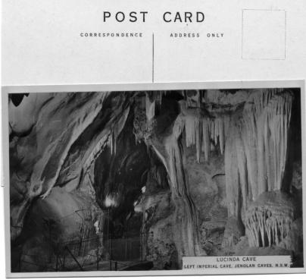
JH1A
JH1A.1 Lucinda Cave/Left Imperial Cave. Jenolan Caves, N.S.W. H
JH1A.2 Jenolan Caves House/Jenolan Caves. N.S.W. H
JH1A.4 Coral Grotto/Right Imperial Cave. Jenolan Caves, N.S.W. H
JH1A.5 The Crystal City/Right Imperial Cave, Jenolan Caves, N.S.W. H
JH1A.6 Persian Court/Orient Cave, Jenolan Caves, N.S.W. H [ms.14 Nov.1931]
JH1A.7 Nellie's Grotto/Right Imperial Cave, Jenolan Caves, N.S.W. H
JH1A.10 The Broken Column/Lucas Cave. Jenolan Caves. N.S.W. V
JH1A.11 Canopy/Orient Cave, Jenolan Caves, N.S.W. V
JH1A.12 Empress Grotto/Orient Cave, Jenolan Caves, N.S.W. V
JH1A.13 Gem of the South/Temple of Baal, Jenolan Caves, N.S.W. V
JH1A.14 Wing and Altar/Temple of Baal, Jenolan Caves, N.S.W. V
JH1A.15 The Altar and Wings/Temple of Baal, Jenolan Caves, N.S.W. V
JH1A.16 The Grand Column/River Cave, Jenolan Caves, N.S.W. V
JH1A.19 Indian Chamber/Orient Cave, Jenolan Caves, N.S.W. V
JH1A.22 Bath of Venus/Skeleton Cave, Jenolan Caves, N.S.W. V
JH1A.24 Jenolan Caves House/Jenolan Caves, N.S.W. V [distant view]
JH1A.25 Carlotta Arch,/Jenolan Caves, N.S.W. V (white margins trimmed off)
JH1A.32 The Blue Lake,/Jenolan Caves, N.S.W. H [pm.7 Dec.1931]
JH1A.33 Pinnacle Rock/Jenolan Caves, N.S.W. H
(We have a copy with the back rubber-stamped 'Gratuitous Copy'.)
JH1A.34 The Grand Arch,/Jenolan Caves, N.S.W. H (view from outside arch with
group of people on roadway at bridge; title in lower left corner ; similar to
JH1.9 but with fewer people.)
JH1A.35 The Underground River,/Jenolan Caves, N.S.W. H

